Please trade with someone when you can’t come. When you trade, you can trade with anyone on the calendar. Youth trade with youth (indicated by those names in brackets) and adults trade with adults…Please inform Mikka Clear at 282-1947. If for some reason, you wake up on Sunday morning and can’t be there, please call 282-1947 and leave a message.
BB2 (Butterfly) (8:30 Worship) | December 2019 | January 2020 | February 2020
FIRST SUNDAY | 1  Sandy Smith  340-1580  Sharon Anderson  352-1944 | 5  Karl Wehmhoener  687-4087  Debbie Wehmhoener  683-7632 | 2  Shelly Amason  282-8367  (Cora/Sallie Amason)  282-8367
SECOND SUNDAY | 8  Chris Ritchie  433-2541  Kara Ritchie  341-6250 | 12  Rodney Little  683-6021  Debbie Little  683-6021 | 9  Dawn Jones  679-9305  Kerri Jones  679-9982
THIRD SUNDAY | 15  Cindy Mayfield  674-4265  Tong Chen  679-6323 | 19  Sue Norman  622-0639  Jackie Myers  359-0015 | 16  Heather Bradshaw  (615)336-3854  Emily Mitchell  676-3697
FOURTH SUNDAY | 22  11 am service only | 26  Dalia Sosa  517-1326  Kendall Harman  353-7513 | 23  Stacy Sanning  355-7780  Judy Beecher  674-7395
FIFTH SUNDAY | 29  11 am service only | X | X

Please trade with someone when you can’t come. When you trade, you can trade with anyone on the calendar. Youth trade with youth (indicated by those names in brackets) and adults trade with adults. Please inform Mikka Clear at 282-1947. If for some reason, you wake up on Sunday morning and can’t be there, please call 282-1947 and leave a message.
F4 (Pig Room) (8:30 Worship) | December 2019 | January 2020 | February 2020
FIRST SUNDAY | 1  Gregg Clear  282-6070  (Joseph Hockaday)  340-9703 | 5  Rachel Faddis  (775)544-3687  Vincentia Faddis  (775)636-4390 | 2  Becky Carr  674-8518  (Meredith Sanning)  355-7780
SECOND SUNDAY | 8  Sandy Porter  679-3636  Brittanie Wooten  355-5639 | 12  Vickie Scarberry  352-2625  Kandy Price  352-3066 | 9  Blake Hockaday  340-9702  Valerie Hockaday  340-9703
THIRD SUNDAY | 15  Terry Mayfield  354-0991  Mickie Knapp  683-9771 | 19  Tania Arands  206-1899  (Allene Arands)  206-1899 | 16  Josh Sprock  570-3260  April Sprock  570-3260
FOURTH SUNDAY | 22  11 am service only | 26  Linda Wesson  570-7759  Pam Ellis  236-6145 | 23  John Hancock  672-5026  Carolyn Hancock  672-5026
FIFTH SUNDAY | 29  11 am service only | X | X

Please trade with someone when you can’t come. When you trade, you can trade with anyone on the calendar. Youth trade with youth (indicated by those names in brackets) and adults trade with adults. Please inform Mikka Clear at 282-1947. If for some reason, you wake up on Sunday morning and can’t be there, please call 282-1947 and leave a message.
X

F7 (Pig Room) (8:30 Worship) |  |  | December 2019 |  | January 2020 |  | February 2020
FIRST SUNDAY |  |  | 1 |  | 5 |  | 2
SECOND SUNDAY |  |  | 8 |  | 12 |  | 9
THIRD SUNDAY |  |  | 15 |  | 19 |  | 16
FOURTH SUNDAY |  |  | 22  Angela Woolard  410-9685  Candy Marshall  570-6165 |  | 26  Linda Wesson  570-7759  Pam Ellis  11 am service only  336-3342 |  | 23  Carolyn Hancock  358-7700  John Hancock  358-7700
FIFTH SUNDAY |  |  | 29 |  | X  11 am service only |  | X
 | Please trade with someone when you can’t come. When you trade, you can trade with anyone on the calendar. Youth trade with youth (indicated by those names in brackets) and adults trade with adults…Please inform Mikka Clear at 282-1947. If for some reason, you wake up on Sunday morning and can’t be there, please call 282-1947 and leave a message.
 | F2 (Cat Room) (11:00 Worship) | December 2019 |  | January 2020 |  | February 2020
 | FIRST SUNDAY | 1  Velvet Knight  676-1342  Verslia Newkirk  681-5687 |  | 5  Greg Roberts  433-1464  Nihla Roberts  433-1464 |  | 2  Tara Cortese  433-2434  Lauren Hickmott  654-8459
 | SECOND SUNDAY | 8  Carla Borden  316-6914  Stephanie Holloway  679-5316 |  | 12  Brianne Davis  (650)714-2153  Jessica Pershall  676-9530 |  | 9  Kim Keene  674-4826  Corissa Rossow  575-9904
 | THIRD SUNDAY | 15  Kay Bingham  690-4210  Jerry Crain  355-0692 |  | 19  Phillip Starr  928-9973  Hilary Starr  928-9973 |  | 16  Abok Lual  316-2237  (Allie War)  316-2237
 | FOURTH SUNDAY | 22  Molly Ritchie  433-6295  Devona Smith  11 am service only  676-3400 |  | 26  Wendy Preston  356-8259  Paige Preston  356-8259 |  | 23  Sallye Barnes  341-2311  (Gracie Barnes)  341-2311
 | FIFTH SUNDAY | 29  Kimberly Ford  681-6165  Melissa Broyles  (325)315-8976  11 am service only |  | X |  | X

Please trade with someone when you can’t come. When you trade, you can trade with anyone on the calendar. Youth trade with youth (indicated by those names in brackets) and adults trade with adults. Please inform Mikka Clear at 282-1947. If for some reason, you wake up on Sunday morning and can’t be there, please call 282-1947 and leave a message.
F4 (Horse Room) (11:00 Worship) |  |  | December 2019 |  | January 2020 | February 2020
FIRST SUNDAY |  |  | 1  Christie Young  622-8689  (Emery Young)  622-8689 |  | 5  Erica Wilkes  437-7010  (Yuvia Wilkes)  437-7010 | 2  Diane Brown  679-7237  Gerald Atchison  353-2564  (Coralynn Coapland)  678-8137
SECOND SUNDAY |  |  | 8  Chris Hauck  570-0285  Keelie Hauck  367-3885 |  | 12  Theresa Avin  236-1932  Jennifer Watson  (936)-435-4664 | 9  Lindsey Fuller  (940)395-1202  Jonas Fuller  (940)395-1202
THIRD SUNDAY |  |  | 15  Trey Scales  683-7012  Chelsey Scales  570-6705 |  | 19  Daniel Samaniego  290-7671  Maggie Samaniego  290-7671 | 16  Mandy Moles  282-4387  Kenzie Moore  420-8206
FOURTH SUNDAY |  |  | 22  Misty Watt  576-8448  (Taylor Watt)  11 am service only  576-8448 |  | 26  David Pinales  683-3033  Elaine Pinales  683-3033 | 23  Jessica Ray  (432)-213-5519  (Abbie Marshall)  335-6961
FIFTH SUNDAY |  |  | 29  Laurie Dewey  341-7569  Pam Cavitt  676-6924  11 am service only |  | X | X
 | Please trade with someone when you can’t come. When you trade, you can trade with anyone on the calendar. Youth trade with youth (indicated by those names in brackets) and adults trade with adults. Please inform Mikka Clear at 282-1947. If for some reason, you wake up on Sunday morning and can’t be there, please call 282-1947 and leave a message.
 | Z2 (Elephant Room) (11:00 Worship) | December 2019 |  | January 2020 |  |  | February 2020
 | FIRST SUNDAY | 1  Shirley Fuentes  353-8588  Cheri Mooring  677-3238 |  | 5  Berry Felder  340-2710  Donna Felder  373-2203 |  |  | 2  Jared Knight  676-8985  (Sterling Knight)  676-4942
 | SECOND SUNDAY | 8  Amy Hebert  (214)886-8389  (Jenna Hebert)  (214)886-8389 |  | 12  Aaron Gollihugh  570-4950  Amber Gollihugh  570-4950 |  |  | 9  Stan Holloway  679-3906  Stephanie Holloway  649-5316
 | THIRD SUNDAY | 15  Jack Shull  (231)360-1907  (Alana Shull)  (231)360-1907 |  | 19  Brad Stuteville  340- 4115  Anna Stuteville  367-3962 |  |  | 16  Charles Chivington  650-1368  Abigail Chivington  650-1368
 | FOURTH SUNDAY | 22  Jeri Lunsford  359-4876  Randy Lunsford  11 am service only  359-4876 |  | 26  Monty Williams  359-0389  Stephanie Williams  359-0389 |  |  | 23  Wade Cavitt  676-6934  (Abby Cavitt)  676-6934
 | FIFTH SUNDAY | 29  Sheryll Malone  443-6984  Corina Hyer  351-1489  11 am service only |  | X |  |  | X

Please trade with someone when you can’t come. When you trade, you can trade with anyone on the calendar. Youth trade with youth (indicated by those names in brackets) and adults trade with adults. Please inform Ranell Garner at 570-0663. If for some reason, you wake up on Sunday morning and can’t be there, please call 570-0663 and leave a message.
4&5 Worship (Rm 212) (11:00) | December 2019 | January 2020 | February 2020
FIRST SUNDAY | 1  Deanna Oeschger  679-3201  (Bryce Oeschger)  679-3201 | 5  Dustin Roberts  674-1663  Natalie Roberts  674-1663 | 2  (Trevor Anderson)  468-8338  (Camden Garza)  236-8455
SECOND SUNDAY | 8  Kristin Babbitt  670-6420  Jarrod Babbitt  690-1343  (Bella Babbitt)  670-6420 | 12  Lee Hickmott  223-8591  Lauren Hickmott  654-8459 | 9  (Denzley Garza)  236-8455  (Kaylee Anderson)  468-8338  (Nevaeh LeBlanc)  674-5538
THIRD SUNDAY | 15  Theresa Avin  236-1932  (Landon Avin)  236-1932 | 19  Justin Fortenberry  420-2620  Joyce Fortenberry  420-2620 | 16  (Jenna Hebert)  (214)-886-8389
FOURTH SUNDAY | 22  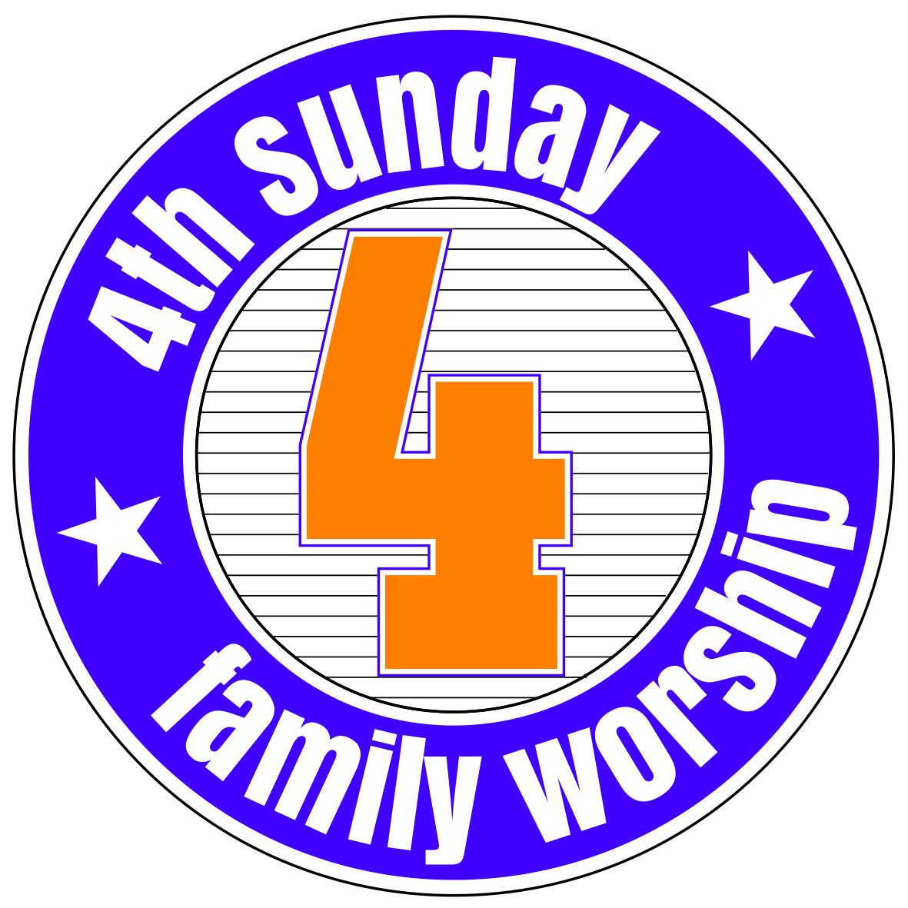 | 26 | 23
FIFTH SUNDAY | 29  11 am service only | X | X

