Please trade with someone when you can’t come. When you trade, you can trade with anyone on the calendar. Youth trade with youth (indicated by those names in brackets) and adults trade with adults…Please inform Mikka Clear at 282-1947. If for some reason, you wake up on Sunday morning and can’t be there, please call 282-1947 and leave a message.
BB2 (Butterfly) (8:30 Worship) | June 2019 | July 2019 | August 2019
FIRST SUNDAY | 2  Sandy Smith  340-1580  Sharon Anderson  352-1944 | 7  Dawn Jones  679-9305  Kerri Jones  679-9982 | 4  Chris Ritchie  433-2541  Kara Ritchie  341-6250
SECOND SUNDAY | 9  Anthony Maldonado  676-2153  Mandie Maldonado  676-1853 | 14  Rodney Little  683-6021  Debbie Little  683-6021 | 11  Connie Blaut  354-9455  Brittany Taute  683-4077
THIRD SUNDAY | 16  Cindy Mayfield  674-4265  Shelly Amason  282-8367 | 21  Sue Norman  622-0639  Jackie Myers  359-0015 | 18  Heather Bradshaw  (615)336-3854  Emily Mitchell  676-3697
FOURTH SUNDAY | 23  Linda Parker  355-2396 | 28  Dalia Sosa  517-1326  Kendall Harman  353-7513 | 25  Stacy Sanning  355-7780  Judy Beecher  674-7395
FIFTH SUNDAY | 30  Karl Wehmhoener  687-4087  Debbie Wehmhoener  683-7632 | X | X

Please trade with someone when you can’t come. When you trade, you can trade with anyone on the calendar. Youth trade with youth (indicated by those names in brackets) and adults trade with adults. Please inform Mikka Clear at 282-1947. If for some reason, you wake up on Sunday morning and can’t be there, please call 282-1947 and leave a message.
F4 (Horse Room) (8:30 Worship) | June 2019 | July 2019 | August 2019
FIRST SUNDAY | 2  Gregg Clear  282-6070  (Joseph Hockaday)  340-9703 | 7  Rachel Faddis  (775)544-3687  Vincentia Faddis  (775)636-4390 | 4  Becky Carr  674-8518  (Meredith Sanning)  355-7780
SECOND SUNDAY | 9  Sandy Porter  679-3636  Bev Williams  236-5873 | 14  Leigha Barnes  678-9383  Jonathan Barnes  683-1201 | 11  Blake Hockaday  340-9702  Valerie Hockaday  340-9703
THIRD SUNDAY | 16  Terry Mayfield  354-0991  Mickie Knapp  683-9771 | 21  Tania Arands  206-1899  (Allene Arands)  206-1899 | 18
FOURTH SUNDAY | 23  Brittanie Wooten  355-5639  Cinda Callaway  322-4088 | 28  Vicki Scarberry  352-2625  Kandy Price  352-3066 | 25
FIFTH SUNDAY | 30  Shelly O’Grady  679-8441  (Carson Ozbun)  640-4100 | X | X

 | Please trade with someone when you can’t come. When you trade, you can trade with anyone on the calendar. Youth trade with youth (indicated by those names in brackets) and adults trade with adults. Please inform Mikka Clear at 282-1947. If for some reason, you wake up on Sunday morning and can’t be there, please call 282-1947 and leave a message.
F7 (Pig Room) (8:30 Worship) |  |  |  | June 2019 |  | July 2019 |  | August 2019
FIRST SUNDAY |  |  |  | 2 |  | 7 |  | 4
SECOND SUNDAY |  |  |  | 9 |  | 14 |  | 11
THIRD SUNDAY |  |  |  | 16 |  | 21 |  | 18
FOURTH SUNDAY |  |  |  | 23  Angela Woolard  410-9685  Candy Marshall  570-6165 |  | 28  Linda Wesson  570-7759  Pam Ellis  336-3342 |  | 25  Carolyn Hancock  358-7700  John Hancock  358-7700
FIFTH SUNDAY |  |  |  | 30 |  | X |  | X
 | Please trade with someone when you can’t come. When you trade, you can trade with anyone on the calendar. Youth trade with youth (indicated by those names in brackets) and adults trade with adults…Please inform Mikka Clear at 282-1947. If for some reason, you wake up on Sunday morning and can’t be there, please call 282-1947 and leave a message.
 |  | F2 (Cat Room) (11:00 Worship) | June 2019 |  | July 2019 |  | August 2019
 |  | FIRST SUNDAY | 2  Velvet Knight  676-1342  Verslia Newkirk  681-5687 |  | 7  Greg Roberts  433-1464  Nihla Roberts  433-1464 |  | 4  Tara Cortese  433-2434  Lauren Hickmott  654-8459
 |  | SECOND SUNDAY | 9  Carla Borden  316-6914  Molly Ritchie  433-6295 |  | 14  Brianne Davis  (650)714-2153  Jessica Pershall  676-9530 |  | 11  Kim Keene  674-4826  Kerra Meurer  679-7719
 |  | THIRD SUNDAY | 16  Kay Bingham  690-4210  Jerry Crain  355-0692 |  | 21  Phillip Starr  928-9973  Hilary Starr  928-9973 |  | 18  Corissa Rossow  (979)575-9904  (Allie War)  316-2237
 |  | FOURTH SUNDAY | 23  Theresa Avin  236-1932  Jennifer Watson  (936)435-4664 |  | 28  Wendy Preston  356-8259  Paige Preston  356-8259 |  | 25  Sallye Barnes  341-2311  (Gracie Barnes)  341-2311
 |  | FIFTH SUNDAY | 30  Stephanie Holloway  679-5316  Devona Smith  676-3400 |  | X |  | X

Please trade with someone when you can’t come. When you trade, you can trade with anyone on the calendar. Youth trade with youth (indicated by those names in brackets) and adults trade with adults. Please inform Mikka Clear at 282-1947. If for some reason, you wake up on Sunday morning and can’t be there, please call 282-1947 and leave a message.
F4 (Horse Room) (11:00 Worship) |  |  | June 2019 |  | July 2019 | August 2019
FIRST SUNDAY |  |  | 2  Christie Young  622-8689  (Emery Young)  622-8689 |  | 7  Josh Sprock  570-3260  April Sprock  570-3260 | 4  Diane Brown  679-7237  Gerald Atchison  353-2564  (Coralynn Coapland)  678-8137
SECOND SUNDAY |  |  | 9  Tong Chen  358-3509  Abby Crump  352-7887 |  | 14  Kimberly Ford  681-6165  (Lindsey Bolin)  678-0029 | 11  Lindsey Fuller  (940)395-1202  Jonas Fuller  (940)395-1202
THIRD SUNDAY |  |  | 16  Erica Wilkes  382-4029  (Yuvia Wilkes)  382-4029 |  | 21  David Pinales  683-3033  Elaine Pinales  683-3033 | 18  Chris Hauck  570-0285  Keelie Hauck  367-3885
FOURTH SUNDAY |  |  | 23  Misty Watt  576-8448  (Taylor Watt)  576-8448 |  | 28  Daniel Samaniego  290-7671  Maggie Samaniego  290-7671 | 25  Jenna Ford  (817)565-2056  Jessica Ray  (432)213-5519
FIFTH SUNDAY |  |  | 30  Laurie Dewey  341-7569  Pam Cavitt  676-6924 |  | X | X
 | Please trade with someone when you can’t come. When you trade, you can trade with anyone on the calendar. Youth trade with youth (indicated by those names in brackets) and adults trade with adults. Please inform Mikka Clear at 282-1947. If for some reason, you wake up on Sunday morning and can’t be there, please call 282-1947 and leave a message.
 | Z2 (Elephant Room) (11:00 Worship) | June 2019 |  | July 2019 |  |  | August 2019
 | FIRST SUNDAY | 2  Shirley Fuentes  353-8588  Cheri Mooring  677-3238 |  | 7  Melissa Broyles  (325)315-8976  (Trevor Anderson)  468-8338 |  |  | 4  Jared Knight  676-8985  (Sterling Knight)  676-4942
 | SECOND SUNDAY | 9  Brittany McAlexander  584-0607  Amy Hebert  (214)886-8389 |  | 14  Corina Hyer  351-1489  Julia Kendrick  676-5594 |  |  | 11  Stan Holloway  679-3906  Stephanie Holloway  649-5316
 | THIRD SUNDAY | 16  Jack Shull  (231)360-1907  (Alana Shull)  (231)360-1907 |  | 21  Brad Stuteville  340- 4115  Anna Stuteville  367-3962 |  |  | 18  Wade Cavitt  676-6934  (Abby Cavitt)  676-6934  Kristin Meurer  679-7719
 | FOURTH SUNDAY | 23  Jeri Lunsford  359-4876  Randy Lunsford  359-4876 |  | 28  Berry Felder  340-2710  Donna Felder  373-2203 |  |  | 25  Dustin Roberts  674-1663  Natalie Roberts  773-3777
 | FIFTH SUNDAY | 30  Sheryll Malone  443-6984  (Janie Malone)  443-6983 |  | X |  |  | X

Please trade with someone when you can’t come. When you trade, you can trade with anyone on the calendar. Youth trade with youth (indicated by those names in brackets) and adults trade with adults. Please inform Ranell Garner at 570-0663. If for some reason, you wake up on Sunday morning and can’t be there, please call 570-0663 and leave a message.
4&5 Worship (Rm 212) (11:00) | June 2019 | July 2019 | August 2019
FIRST SUNDAY | 2  Deanna Oeschger  679-3201  (Bryce Oeschger)  679-3201 | 7 | 4  (Trevor Anderson)  468-8338  (Camden Garza)  236-8455
SECOND SUNDAY | 9 | 14  Lee Hickmott  223-8591  Lauren Hickmott  654-8459 | 11  (Denzley Garza)  236-8455  (Kaylee Anderson)  468-8338  (Nevaeh LeBlanc)  674-5538
THIRD SUNDAY | 16  Caleb Baker  443-5445  Courtney Baker  443-5445 | 21  (Kaitlyn Craddock)  463-0024  (Avery Garza)  236-8455 | 18  Zach Craddock  463-0024  D’ann Craddock  463-0024
FOURTH SUNDAY | 23  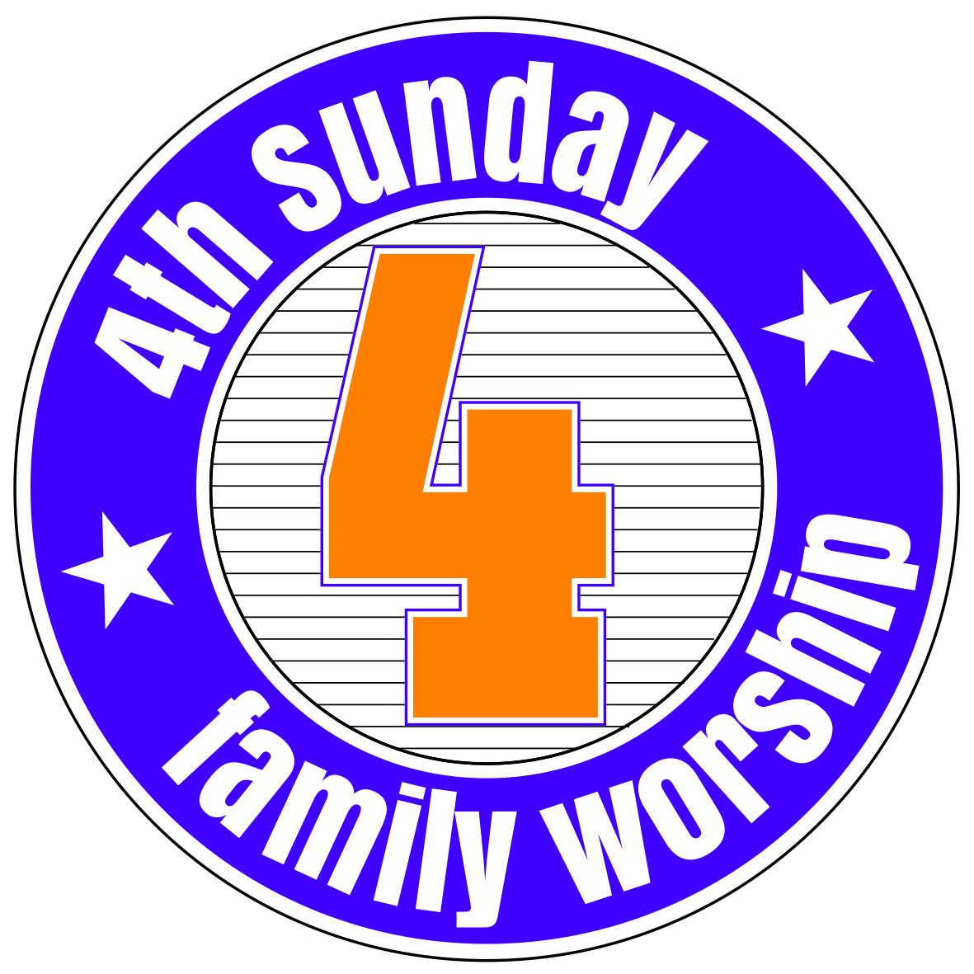 | 28 | 25
FIFTH SUNDAY | 30 | X | X

